1. Student information System useing PHP and MYSQL
- ADD Student
- DELETE Student
- MODEFY Student Information
- Search Student Information
Code
Main.php
<html>
<head>
<link rel="stylesheet" href="style.css">
<!--<style>

.button{
text-align:center;
margin:6px 4px;
cursor:pointer;
background-color:#4caf50;
color:#fff;
padding:15px 32px;
border:none;
}
</style> -->

</head>
<body>
<h1>WELCOME CHIEF...!</h1>
<h2>What would you like to do here?</h2>
<br>
<div class="wrapper">
<a class="button" href="upload.php">Add Student</a>
<a class="button" href="search.php">Search Student</a>
</div>
</body>
</html>

Search.php

<html>
<head>
<title>search profile</title>
<link rel="stylesheet" href="style.css">

</head>
<body>
<h1>Search Student</h1>
<form name=search method="post" action="">
<a>University Roll No : <input type=text size=20 name="uroll" id="urol"></a>
<input type=submit name=search value=Search class="button">

<br><br><br><br>
</form>

<?php
$conn =mysqli_connect("localhost","root","","stdntdb");
if(!$conn)
{
die("Not able to connect");
}
if(isset($_REQUEST['search']))
{
$urol=$_REQUEST['uroll'];

if($urol!="")
{
$query="select * from stdntdata where uroll='$urol'";
$query_run=mysqli_query($conn,$query);

while($row=mysqli_fetch_array($query_run))
{
?>
<form action="" method="POST">
<p>Student Details</p>
<a>University Roll No : <input type=text name="uroll" disabled value="<?php echo $row['uroll']?>"></a>
<a>Stream : <input type=text name="stream" disabled value="<?php echo $row['stream']?>"></a>
<a>Name : <input type=text name="name" disabled value="<?php echo $row['name']?>"></a>
<a>Gender : <input type=text name="gender" disabled value="<?php echo $row['gender']?>"></a><br><br>
<a>Date Of Birth : <input type=text name="dob" disabled value="<?php echo $row['dob']?>"></a>
<a>Present Address : <input type=text name="address" disabled value="<?php echo $row['address']?>"></a>
<a>Email id : <input type=email name="email" disabled value="<?php echo $row['email']?>">
<a>Mobile No : <input type=text name="no" disabled value="<?php echo $row['phone']?>"></a>

<br>

<p>10th Standard</p>
<a>Exam Name : <input type=text name="tenthexam" disabled value="<?php echo $row['10examName']?>"></a>
<a>Board/Council : <input type=text name="tenthboard" disabled value="<?php echo $row['10examBoard']?>"></a>
<a>Year Of Passing : <input type=text name="tenthyear" disabled value="<?php echo $row['10examYear']?>"></a><br><br>
<a>%Marks in Aggregate : <input type=text name="tenthmarks" disabled value="<?php echo $row['10examMarks']?>"></a>

<br>

<p>12th Standard</p>
<a>Exam Name : <input type=text name="twlvthexam" disabled value="<?php echo $row['12examName']?>"></a>
<a>Board/Council : <input type=text name="twlvthboard" disabled value="<?php echo $row['12examBoard']?>"></a>
<a>Year Of Passing : <input type=text name="twlvthyear" disabled value="<?php echo $row['12examYear']?>"></a><br><br>
<a>%Marks in Aggregate : <input type=text name="twlvthmarks" disabled value="<?php echo $row['12examMarks']?>"></a>
<div class="wrapper">
<a class="button" href="update.php?update=<?php echo $row['uroll'] ?>">Update Data</a>
<a class="button" href="search.php?delete=<?php echo $row['uroll'] ?>" onclick="return confirm('Are You Sure You Want to Delete this?')">Delete</a><br><br>
</div>
</form>

<?php

}
}
else
{
echo '<span style="color:#fff;font-size:25px;text-align: center;">All Fields Required !!</span>';
}
}

?>
<div class="wrapper">
<a href="main.php" class="button">Go Home</a>
</div>
</body>
</html>

<?php
$conn =mysqli_connect("localhost","root","","stdntdb");
if(!$conn)
{
die("Not able to connect");
}

$id="";
if(isset($_GET['delete']))
$id = $_GET['delete'];

//echo $id;
$query1="delete from stdntdata where uroll= '$id'";
$run=mysqli_query($conn,$query1);
if($run)
{
if(mysqli_affected_rows($conn)>0)
{
echo '<span style="color:#fff;font-size:25px;">Deleted successfully..!!</span>';
}
else
{
//echo "Sorry,Permission Denied";
}
}

?>

style.css

body
{
background-color:#003380;
}

a
{
margin-left:2%;
padding:10px 4px;
color:#fff;
}

h
{
font-size:45px;
text-align: center;
margin-left:38%;
}

h1
{
text-align:center;
color:#262626;
font-size:50px;
color:#fff;
margin-top:15vh;
}

h2
{
color: #fff;
text-align:center;
font-size:40px;
margin-top:10vh;
}
p
{
font-size:30px;
font-family:ariel;
margin-left: 3%;
color:#ffcc00;
}
.wrapper
{
text-align:center;
margin-top:2vh;
}
.button{
text-align:center;
margin:6px 4px;
cursor:pointer;
background-color:#267326;
color:#fff;
padding:15px 32px;
border:none;
font-weight:bold;
}

#visibility
{
visibility:hidden;
}

Update.php

<?php
$update_val="";
if(isset($_GET['update']))
$update_val = $_GET['update'];

//echo $update_val;
?>

<?php
if(isset($_REQUEST['up']))
{
$conn =mysqli_connect("localhost","root","","stdntdb");
if(!$conn)
{
die("Not able to connect");
}

$strm=$_REQUEST['stream'];
$name=$_REQUEST['name'];
$gender=$_REQUEST['gender'];
$dob=$_REQUEST['dob'];
$address=$_REQUEST['address'];
$eml=$_REQUEST['email'];
$mob=$_REQUEST['no'];
$tenthexam=$_REQUEST['tenthexam'];
$tenthboard=$_REQUEST['tenthboard'];
$tenthyear=$_REQUEST['tenthyear'];
$tenthmarks=$_REQUEST['tenthmarks'];
$twlvthexam=$_REQUEST['twlvthexam'];
$twlvthboard=$_REQUEST['twlvthboard'];
$twlvthyear=$_REQUEST['twlvthyear'];
$twlvthmarks=$_REQUEST['twlvthmarks'];

if($strm!="" && $name!="" && $gender!="" && $dob!="" && $address!="" && $eml!="" && $mob!="" && $tenthexam!="" && $tenthboard!="" && $tenthyear!="" && $tenthmarks!="" && $twlvthexam!="" && $twlvthboard!="" && $twlvthyear!="" && $twlvthmarks!="")
{

$sql="update stdntdata set stream='$strm',name='$name',gender='$gender',dob='$dob',address='$address',email='$eml',phone='$mob',10examName='$tenthexam',10examBoard='$tenthboard',10examYear='$tenthyear',10examMarks='$tenthmarks',12examName='$twlvthexam',12examBoard='$twlvthboard',12examYear='$twlvthyear',12examMarks='$twlvthmarks' where uroll= '$update_val'";
$rows=mysqli_query($conn,$sql);
if(!$rows)
{
echo '<span style="color:#fff;font-size:25px;">Cannot Update Data!!</span>';
}
else
echo '<span style="color:#fff;font-size:25px;">Data Updated Successfully!</span>';
}
else
{
echo '<span style="color:#fff;font-size:25px;text-align: center;">All Fields Required !!</span>';
}
}
?>

<html>
<head>
<title>upload profile</title>
<link rel="stylesheet" href="style.css">
</head>
<body>
<h1>Update Student Details</h1>
<form name=update method="post" action="">

<!--<p>Basic Information</p>
<a>University Roll No : <input type=text size=20 name="uroll" disabled value="<?php echo $update_val ?>"></a>
-->
<?php
$conn =mysqli_connect("localhost","root","","stdntdb");
if(!$conn)
{
die("Not able to connect");
}
if(isset($_REQUEST['update']))
{
//$urol=$_REQUEST['uroll'];

if($update_val!="")
{
$query="select * from stdntdata where uroll='$update_val'";
$query_run=mysqli_query($conn,$query);

while($row=mysqli_fetch_array($query_run))
{
?>
<form action="" method="POST">
<p>Student Details</p>
<a>University Roll No : <input type=text name="uroll" disabled value="<?php echo $row['uroll']?>"></a>
<a>Stream : <input list="stream" name="stream" value="<?php echo $row['stream']?>">
<datalist id="stream">
<option value="CSE">
<option value="CS">
<option value="ME">
<option value="EE">
<option value="ECE">
</datalist></a>
<a>Name : <input type=text name="name" value="<?php echo $row['name']?>"></a>
<a>Gender : <input type=text name="gender" value="<?php echo $row['gender']?>"></a><br><br>
<a>Date Of Birth : <input type=date name="dob" value="<?php echo $row['dob']?>"></a>
<a>Present Address : <input type=text name="address" value="<?php echo $row['address']?>"></a>
<a>Email id : <input type=email name="email" value="<?php echo $row['email']?>">
<a>Mobile No : <input type=text name="no" value="<?php echo $row['phone']?>"></a>

<br>

<p>10th Standard</p>
<a>Exam Name : <input type=text name="tenthexam" value="<?php echo $row['10examName']?>"></a>
<a>Board/Council : <input type=text name="tenthboard" value="<?php echo $row['10examBoard']?>"></a>
<a>Year Of Passing : <input type=text name="tenthyear" value="<?php echo $row['10examYear']?>"></a><br><br>
<a>%Marks in Aggregate : <input type=text name="tenthmarks" value="<?php echo $row['10examMarks']?>"></a>

<br>

<p>12th Standard</p>
<a>Exam Name : <input type=text name="twlvthexam" value="<?php echo $row['12examName']?>"></a>
<a>Board/Council : <input type=text name="twlvthboard" value="<?php echo $row['12examBoard']?>"></a>
<a>Year Of Passing : <input type=text name="twlvthyear" value="<?php echo $row['12examYear']?>"></a><br><br>
<a>%Marks in Aggregate : <input type=text name="twlvthmarks" value="<?php echo $row['12examMarks']?>"></a>
<div class="wrapper">
<input type=submit name=up value=Update class="button">
<a class="button" href="main.php">Go Home</a>
<a class="button" href="search.php">Search Another</a><br>
</div>
</form>

<?php

}
}
else
{
echo '<span style="color:#fff;font-size:25px;text-align: center;">All Fields Required !!</span>';
}
}

?>

</body>
</html>

upload.php

<?php
if(isset($_REQUEST['upload']))
{
$conn =mysqli_connect("localhost","root","","stdntdb");
if(!$conn)
{
die("Not able to connect");
}

$urol=$_REQUEST['uroll'];
$strm=$_REQUEST['stream'];
$name=$_REQUEST['name'];
$gender=$_REQUEST['gender'];
$dob=$_REQUEST['dob'];
$address=$_REQUEST['address'];
$eml=$_REQUEST['email'];
$mob=$_REQUEST['no'];

$tenthexam=$_REQUEST['tenthexam'];
$tenthboard=$_REQUEST['tenthboard'];
$tenthyear=$_REQUEST['tenthyear'];
$tenthmarks=$_REQUEST['tenthmarks'];

$twlvthexam=$_REQUEST['twlvthexam'];
$twlvthboard=$_REQUEST['twlvthboard'];
$twlvthyear=$_REQUEST['twlvthyear'];
$twlvthmarks=$_REQUEST['twlvthmarks'];

if($urol!="" && $strm!="" && $name!="" && $gender!="" && $dob!="" && $address!="" && $eml!="" && $mob!="" && $tenthexam!="" && $tenthboard!="" && $tenthyear!="" && $tenthmarks!="" && $twlvthexam!="" && $twlvthboard!="" && $twlvthyear!="" && $twlvthmarks!="")
{

$sql="insert into stdntdata values('$urol','$strm','$name','$gender','$dob','$address','$eml','$mob','$tenthexam','$tenthboard','$tenthyear','$tenthmarks','$twlvthexam','$twlvthboard','$twlvthyear','$twlvthmarks')";
$rows=mysqli_query($conn,$sql);
if($rows==0)
{
echo '<span style="color:#fff;font-size:25px;">Cannot Upload Data!!</span>';
}

else
echo '<span style="color:#fff;font-size:25px;">Data Uploaded Successfully!</span>';
}
else
{
echo '<span style="color:#fff;font-size:25px;text-align: center;">All Fields Required !!</span>';
}
}
?>
<html>
<head>
<title>upload profile</title>
<link rel="stylesheet" href="style.css">
</head>
<body>
<h1>Add Student Details</h1>
<form name=upload method="post" action="">

<p>Basic Information</p>
<a>University Roll No : <input type=text size=20 name="uroll"></a>
<a>Stream : <input list="stream" name="stream">
<datalist id="stream">
<option value="CSE">
<option value="CS">
<option value="ME">
<option value="EE">
<option value="ECE">
</datalist></a>
<a>Name : <input type=text size=20 name="name"></a>
<a>Gender : <input type="radio" name="gender" value="male" checked> Male
<input type="radio" name="gender" value="female"> Female</a><br><br>
<a>Date Of Birth : <input type="date" name="dob"></a>
<a>Present Address : <input type=text size=30 name="address"></a>
<a>Email id : <input type=email size=20 name="email"></a>
<a>Mobile No : <input type=text size=10 name="no"></a>

<br>

<p>10th Standard</p>
<a>Exam Name : <input type=text size=15 name="tenthexam"></a>
<a>Board/Council : <input type=text size=20 name="tenthboard"></a>
<a>Year Of Passing : <input type=text size=4 name="tenthyear"></a><br><br>
<a>%Marks in Aggregate : <input type=text size=5 name="tenthmarks"></a>

<br>

<p>12th Standard</p>
<a>Exam Name : <input type=text size=15 name="twlvthexam"></a>
<a>Board/Council : <input type=text size=20 name="twlvthboard"></a>
<a>Year Of Passing : <input type=text size=4 name="twlvthyear"></a><br><br>
<a>%Marks in Aggregate : <input type=text size=5 name="twlvthmarks"></a>
<br><br><br>
<div class="wrapper">
<input type=submit name=upload value=Upload class="button">
<input type="reset" class="button">
<a href="main.php" class="button">Go Home</a>
</div>
</form>
</body>
</html>

OUTPUT

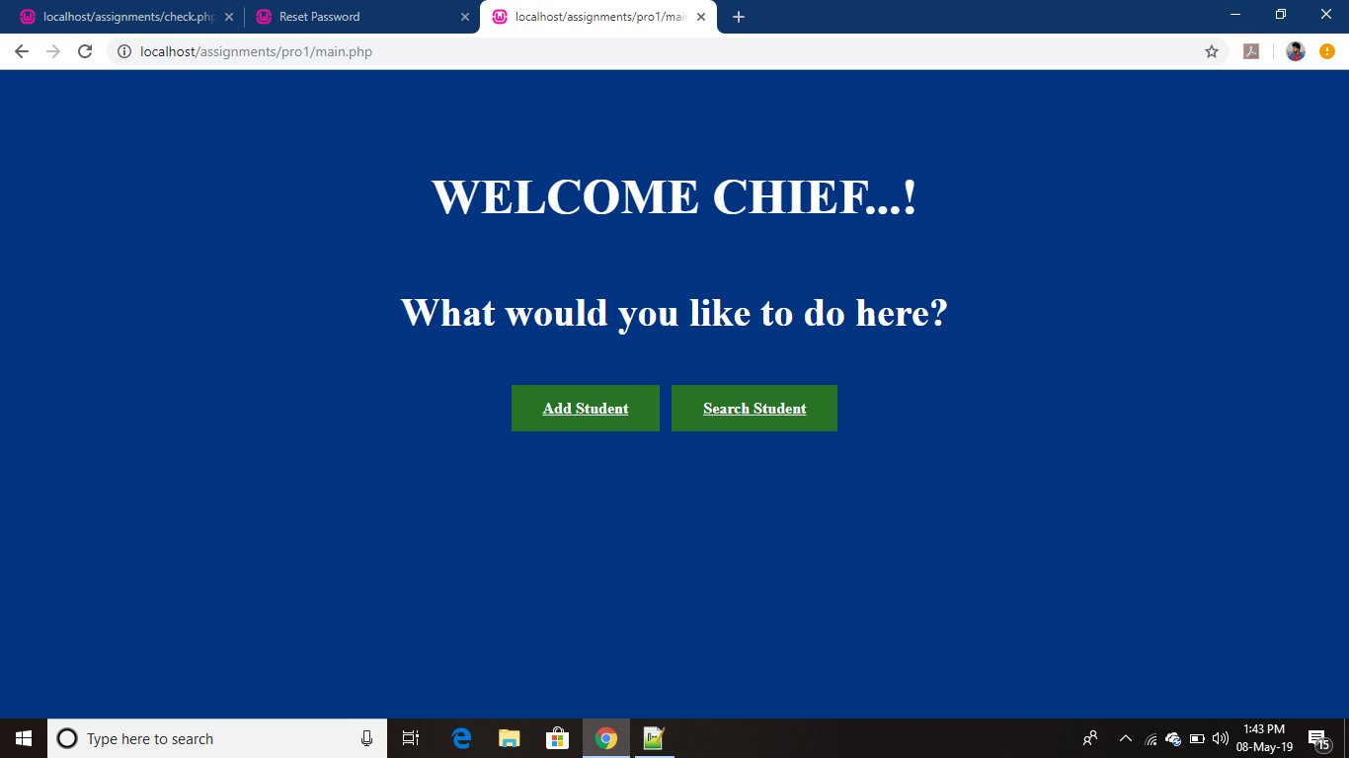

Welcom page

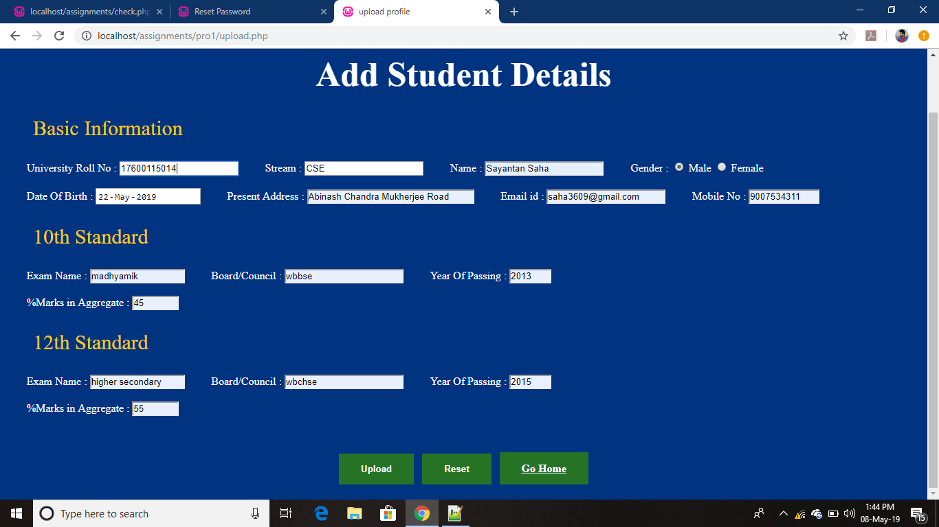
Student informantion added for new entry
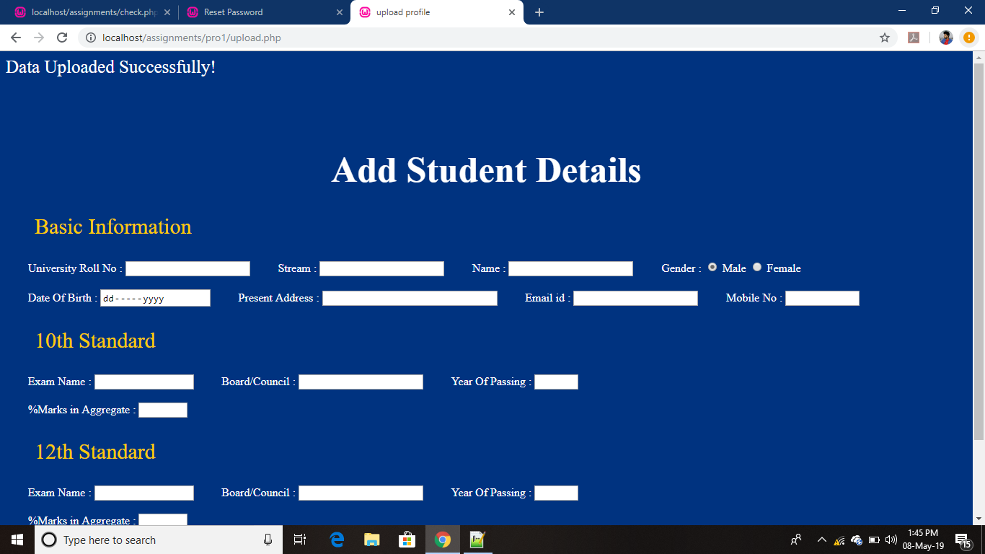

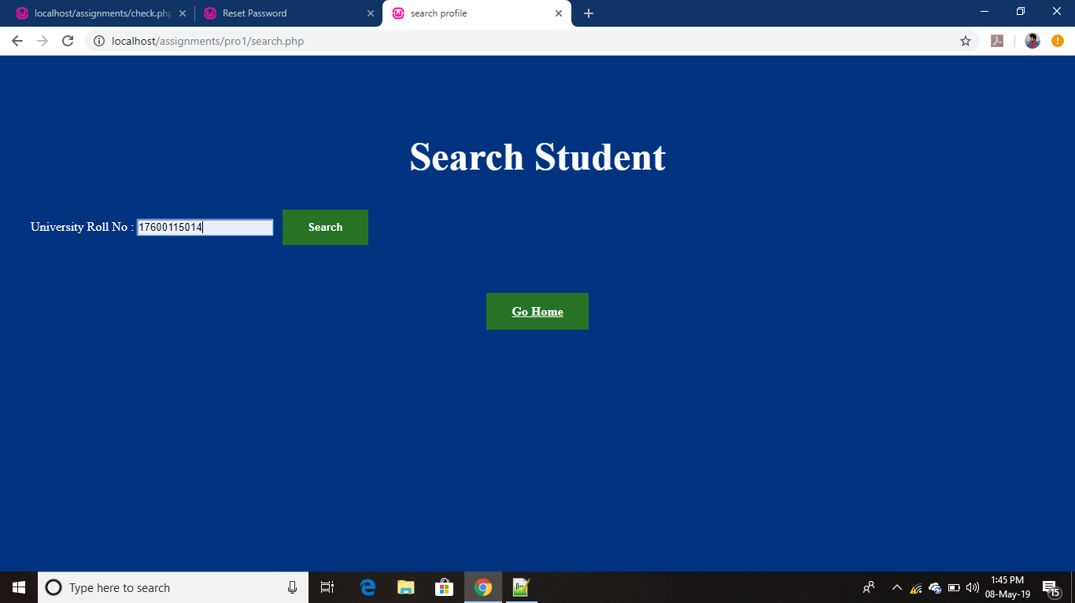
Data uploaded

Searching Student

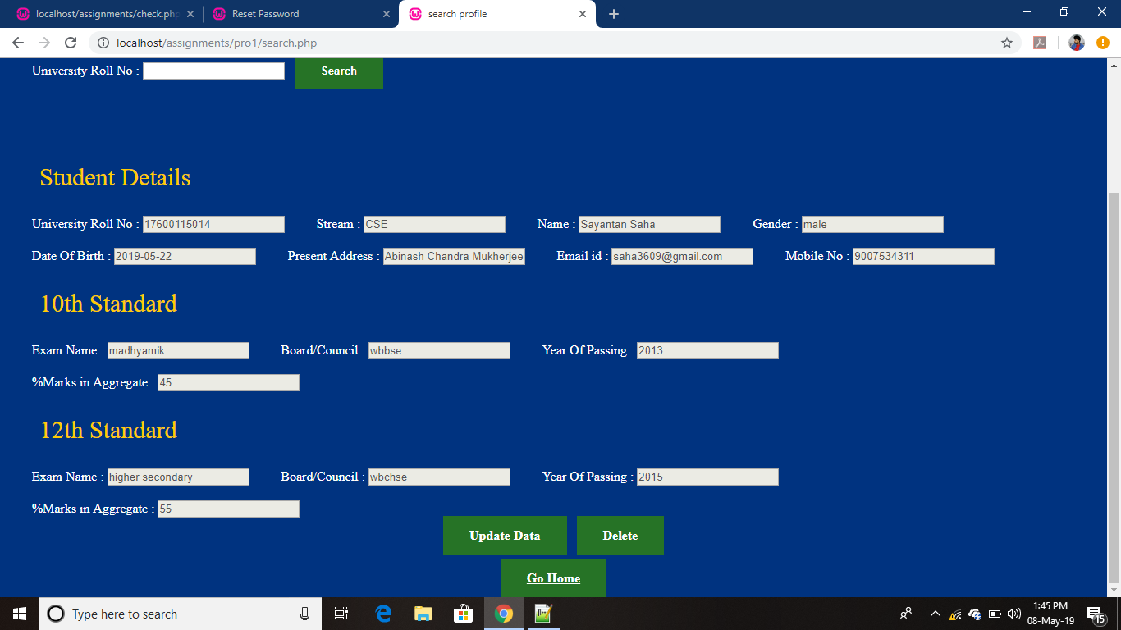
Student data Visible as well as updating information available

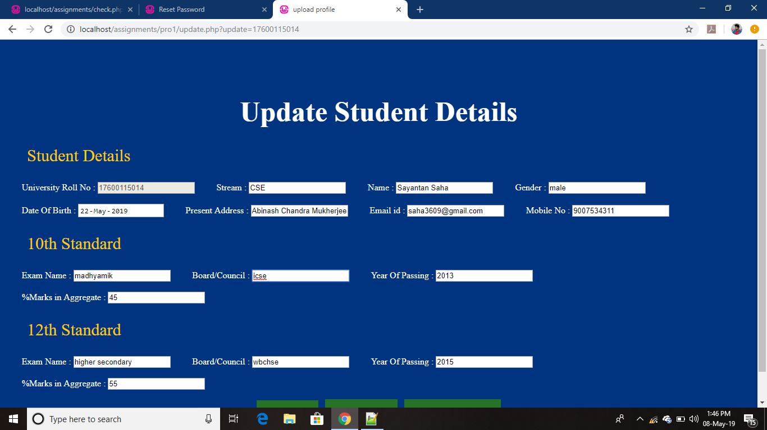
Changing board from Wbse to ICSE and searching again

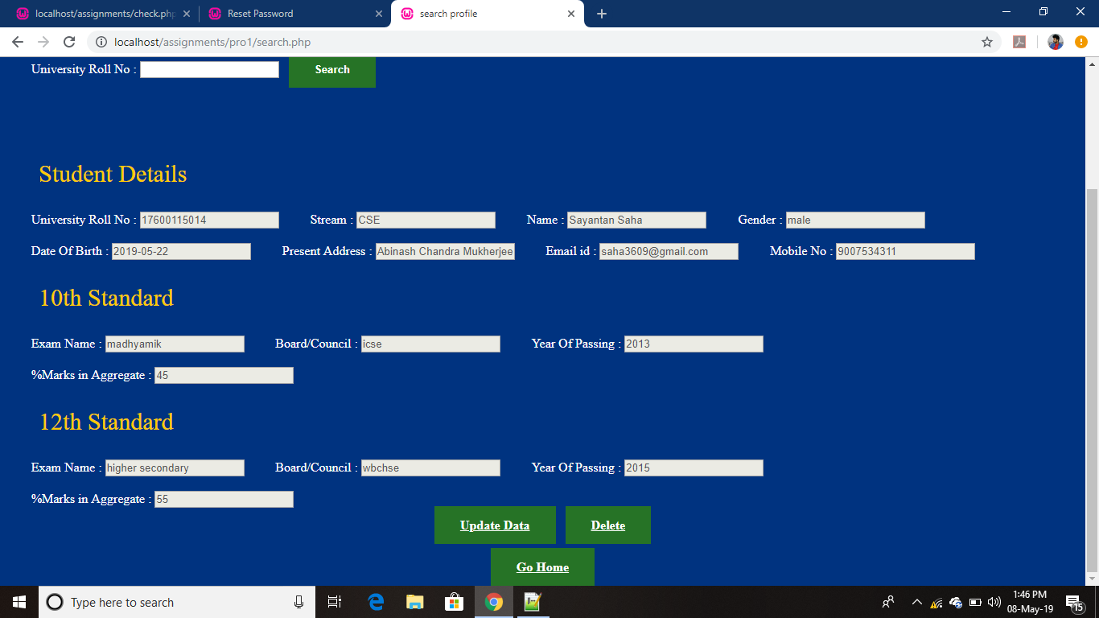
Data updated on clicking the delete button the data get deleted

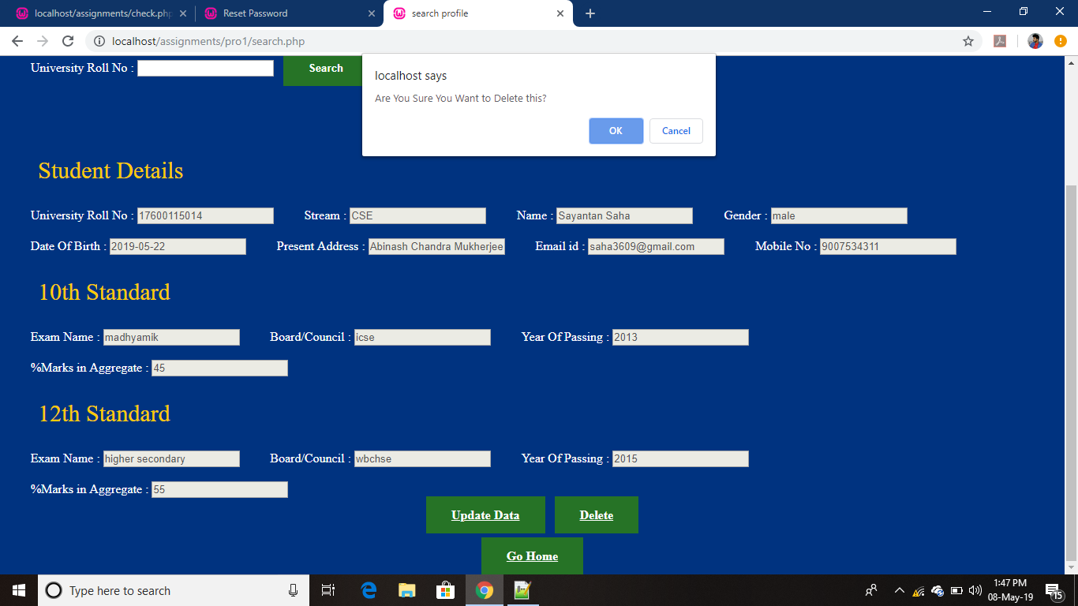
data delete alert generated on confirmation
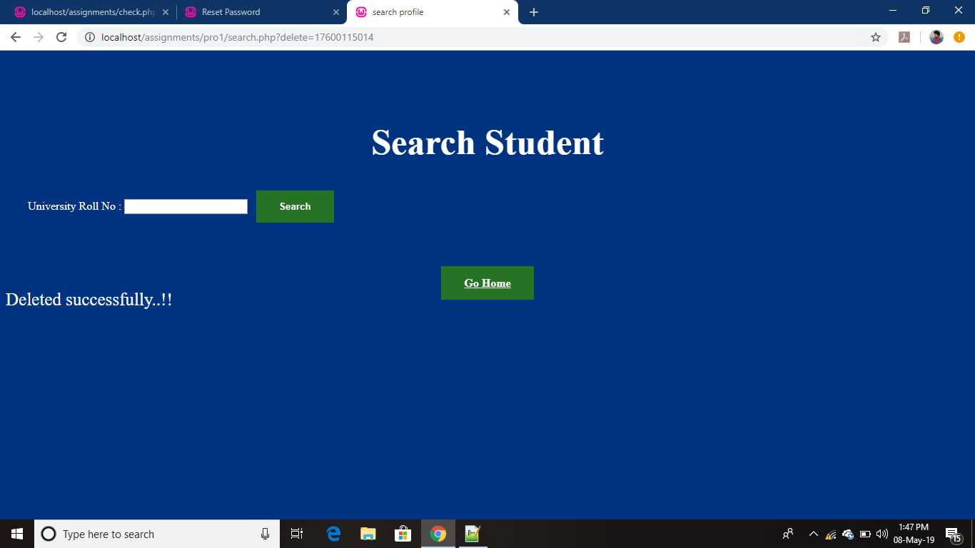

2. Building a full featured login System using PHP and MYSQL
- login page
- new user
- forgot userID or password
Code :-
home.php

<?php
session_start();
error_reporting(0);
$userpro=$_SESSION['username'];
$conn =mysqli_connect("localhost","root","","stdntdb");
if(!$conn)
{
die("Not able to connect");
}

$query="SELECT * FROM `login&reg` WHERE `email`='".$userpro."'";
$query_run=mysqli_query($conn,$query);

while($row=mysqli_fetch_array($query_run))
{
?>
<center>
<h1>Welcome</h1>
<h2> <?php echo $_SESSION['username']?></h2>
<form action="" method="post">
<h2>Your Dashboard:</h2>
<input type="text" name="name" value="<?php echo $row['name']?>"/><br>
<input type="text" name="dob" value="<?php echo $row['dob']?>"/><br>
<input type="text" name="phone" value="<?php echo $row['phone']?>"/><br>
<input type="text" name="password" value="<?php echo $row['password']?>"/>
</form>
<a href="logout.php">Log Out</a>
</center>
<?php
}
//echo "Welcome ".$_SESSION['username'];
?>
<html>
<head>
<link rel="stylesheet" href="style.css">
<title>Dashboard</title>
</head>
<body>

</body>
</html>

Login.php

<?php
session_start();
if(isset($_POST['submit']))
{
$conn =mysqli_connect("localhost","root","","stdntdb");
if(!$conn)
{
die("Not able to connect");
}

$user=$_POST['user'];
$pass=$_POST['pwd'];

$sql="select `email`,`password` from `login&reg` where email='".$user."' && password='".$pass."'";
$result=mysqli_query($conn,$sql);
if(mysqli_num_rows($result))
{
$_SESSION['username']=$user;
header('location:home.php');
}
else
echo '<span style="color:#ff0000;font-size:25px;">There is no record!!</span>';
}

?>
<html>
<head>
<title>Sign in</title>
<link rel="stylesheet" href="style.css">
</head>
<body>
<center>
<form method="post" action="">
<h1>Login Section</h1>

<input type="text" name="user" placeholder="Enter username here"><br>
<input type="password" name="pwd" placeholder="Enter password here"><br>
<input type="submit" name="submit" value="Login">
<br>
<a href="signup.php">Click here to SignUp</a>
<a href="forget.php">Forget Password</a>

</form>
</center>
</body>
</html>

logout .php

<?php
session_start();
session_destroy();
header('location:login.php');

?>

Signup.php

<?php
if(isset($_REQUEST['submit']))
{
$conn =mysqli_connect("localhost","root","","stdntdb");
if(!$conn)
{
die("Not able to connect");
}

$name=$_REQUEST['name'];
$dob=$_REQUEST['dob'];
$eml=$_REQUEST['email'];
$mob=$_REQUEST['phone'];
$conpwd=$_REQUEST['conpwd'];

if($name!="" && $eml!="" && $dob!="" && $mob!="" && $conpwd!="")
{
$sql="INSERT INTO `login&reg`(`name`, `email`, `dob`, `phone`, `password`) VALUES ('".$name."', '".$eml."', '".$dob."', '".$mob."', '".$conpwd."')";
$rows=mysqli_query($conn,$sql);
if($rows==0)
{
echo '<span style="color:#ff0000;font-size:25px;">Cannot Upload Data!!</span>';
}

else
{
header('location:login.php');
}
}
else
{
echo '<span style="color:#ff0000;font-size:25px;text-align: center;">All Fields Required !!</span>';
}
}

?>

<html>
<head>
<title>Sign up</title>
<link rel="stylesheet" href="style.css">
</head>
<body>
<center>
<form method="post" action="">
<h1>Registration Pannel</h1>
<input type="text" name="name" placeholder="enter fullname"><br>
<input type="email" name="email" placeholder="enter email"><br>
<input type="date" name="dob"/><br>
<input type="text" name="phone" placeholder="enter phone no"/><br>
<input id="password" type="password" name="password" placeholder="enter password" onkeyup='check();' /><br>
<input id="conpwd" type="password" name="conpwd" placeholder="re-enter password" onkeyup='check();' />
<span id='message'></span><br>
<input type="submit" name="submit" value="Register">
<br>
<a href="login.php">Already have an account? click here to login</a>
</form>
</center>
<script>
var check = function()
{
if(document.getElementById('password').value == document.getElementById('conpwd').value)
{
document.getElementById('message').style.color = 'green';
document.getElementById('message').innerHTML = 'Matched';
}
else
{
document.getElementById('message').style.color = 'red';
document.getElementById('message').innerHTML = 'Not matched';
}
}
</script>
</body>
</html>

Forget.php

<?php
session_start();

$conn =mysqli_connect("localhost","root","","stdntdb");
if(!$conn)
{
die("Not able to connect");
}

if(isset($_POST['reset']))
{
$eml=$_POST['mail'];

$query="SELECT * FROM `login&reg` WHERE `email`='".$eml."'";
$query_run=mysqli_query($conn,$query);

$row=mysqli_fetch_array($query_run);

$password=$row['password'];

$to =(string)$eml;
$pass=(string)$password;
$subject = "Forget Password";
$message = "your username is: ".$to."\n"."Your password: ".$pass;
$headers = 'FRom: hackers.hack.555@gmail.com';

if(mail($to, $subject, $message, $headers))
{
echo "A mail has been send to ".$to;
}
else
{
echo "Can not send mail";
}
}
?>

<html>
<head>
<title>Reset Password</title>
<link rel="stylesheet" href="style.css">
</head>
<body>
<center>
<form method="post" action="">
<h1>Reset Password</h1>

<input type="email" name="mail" placeholder="example@example.com"><br>
<input type="submit" name="reset" value="Send">
<br>
<a href="login.php">Login Here</a>
</form>
</center>
</body>
</html>

Style.css

body
{

background-color:#e6e6e6;
}

a
{
margin-left:2%;
padding:10px 4px;
font-size:20px;
font-family:ariel
}

h1
{
text-align:center;
color:blueviolet;
font-size:50px;
text-decoration:underline;
margin-top:15vh;
}

h2
{
font-size:30px;
color:blueviolet;
margin-top:auto;

}
input
{
width:40%;
height:5%;
border:1px;
border-radius:05px;
padding:8px 15px 8px 15px;
margin:10px 0px 15px 0px;
box-shadow:1px 1px 2px 1px #808080;
}

Output:

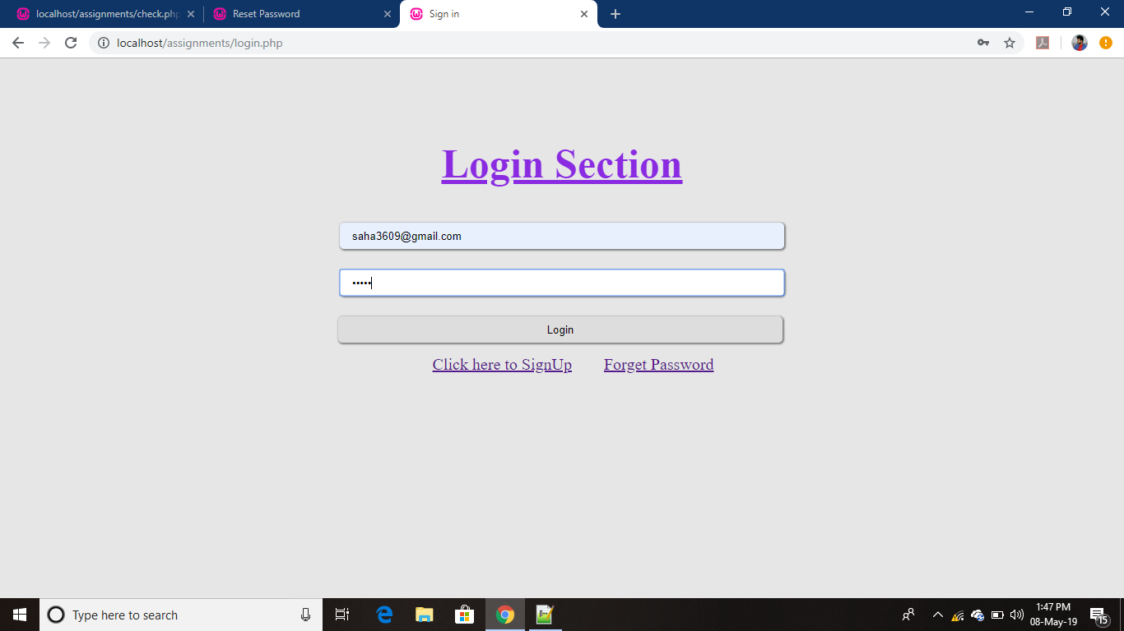
Home page

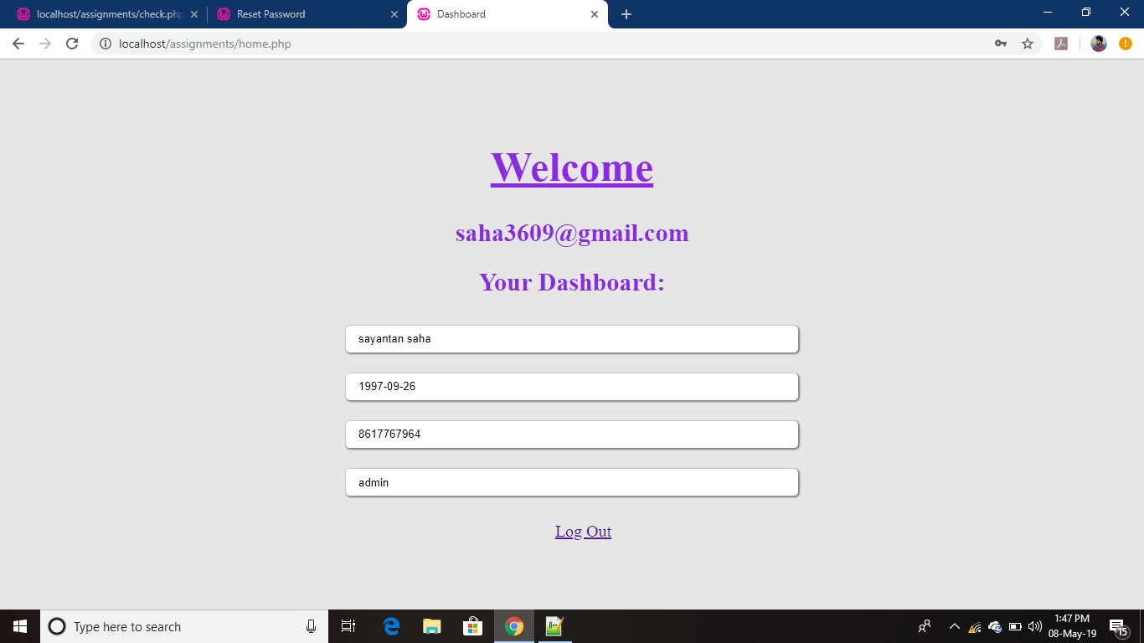
Dashboard page

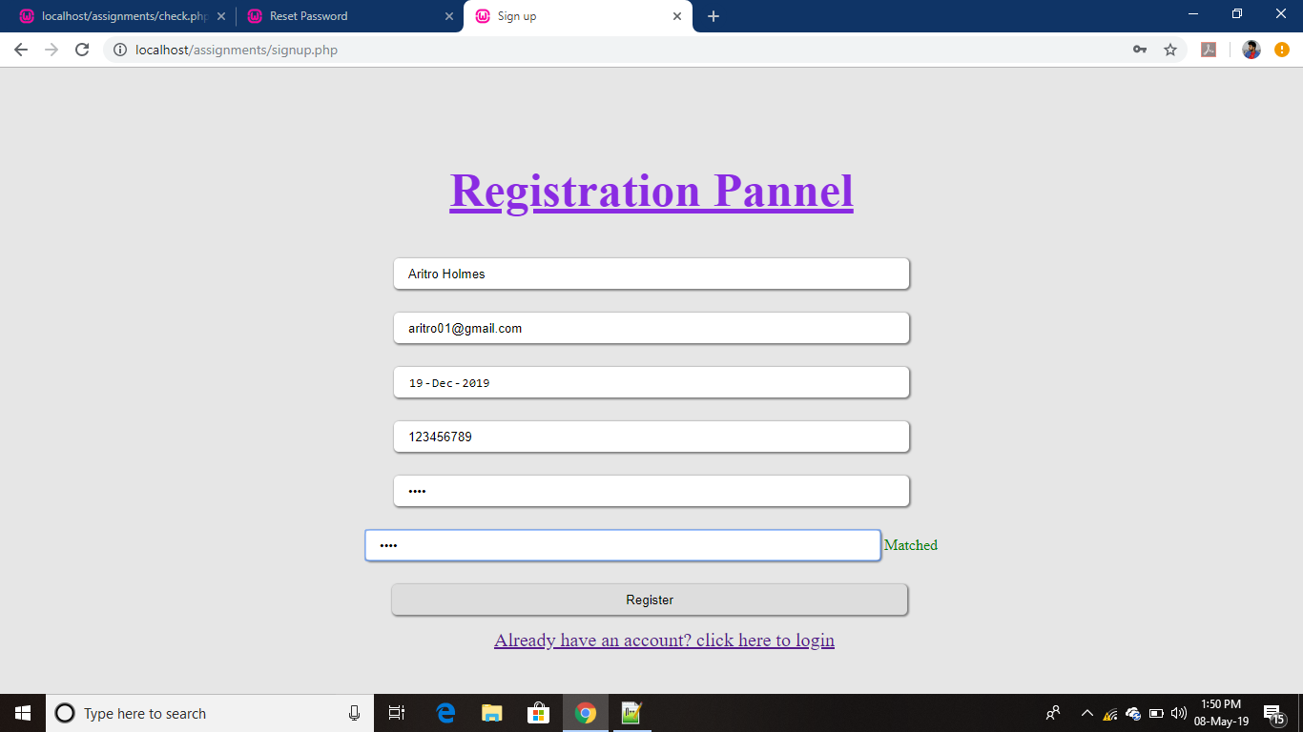

Registration page

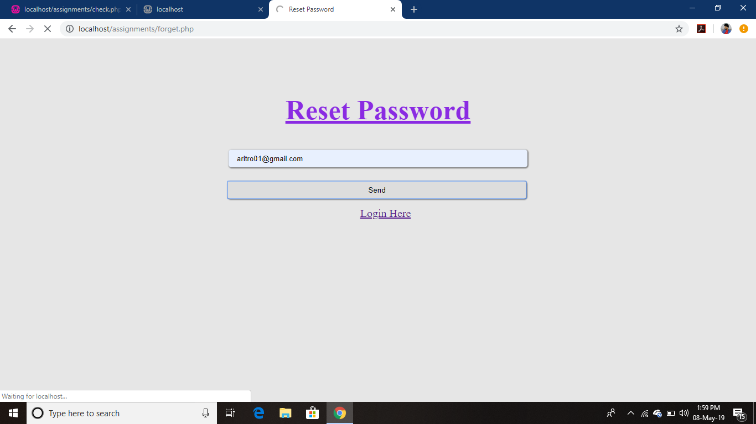
password reset page

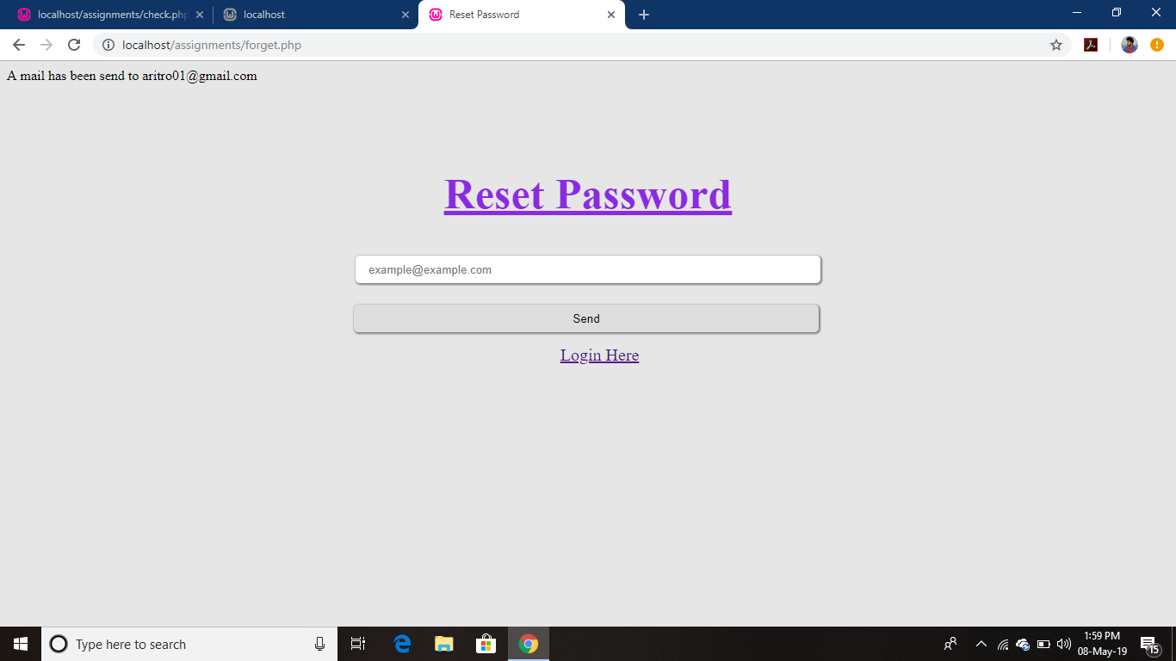

reset mail sent to the mail id

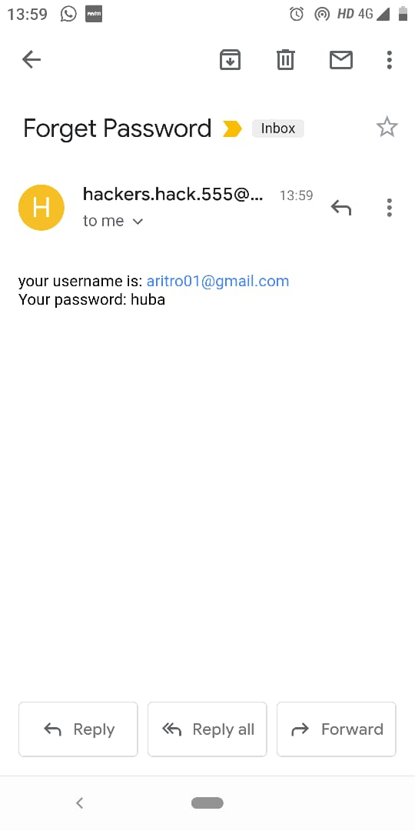

password sent to the intended user

